# Department of Computer Engineering

Internship Report

*Submitted in partial fulfilment of the requirements for the degree of*

# BACHELOR OF ENGINEERING

**In**

# COMPUTER ENGINEERING

*Submitted By*

# Name of the student: Patil Pranav Kumar

# Roll No. 20CO089

Under the Guidance of

**Prof. V. S. Gunjal**

Academic Year: 2022-23(Term-II)

# Savitribai Phule Pune University

**DEPARTMENT OF COMPUTER ENGINEERING**

# CERTIFICATE

This is to certify that **Patil Pranav Kumar** from **Third Year Computer Engineering** has successfully completed his work titled “**Internship Report**” at AISSMS College of Engineering, Pune in the partial fulfilment of the Bachelor’s Degree in Engineering.

**Prof. V. S. Gunjal**

Faculty Guide Computer Engineering

## Dr. S. V. Athawale

HOD

Computer Engineering

**Prof. S. G. Dhengre** Internship Coordinator Computer Engineering

## Dr. D. S. Bormane

Principal AISSMS COE, Pune

# ALLOTMENT LETTER

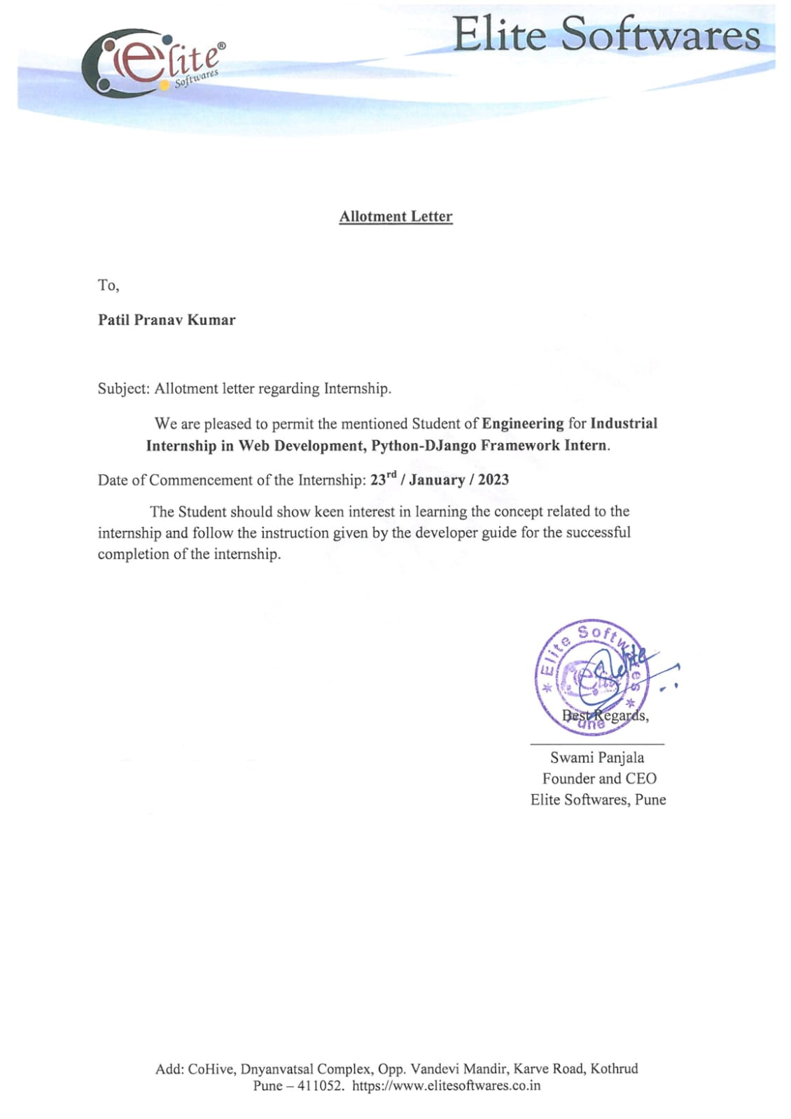

**INTERNSHIP CERTIFICATE**

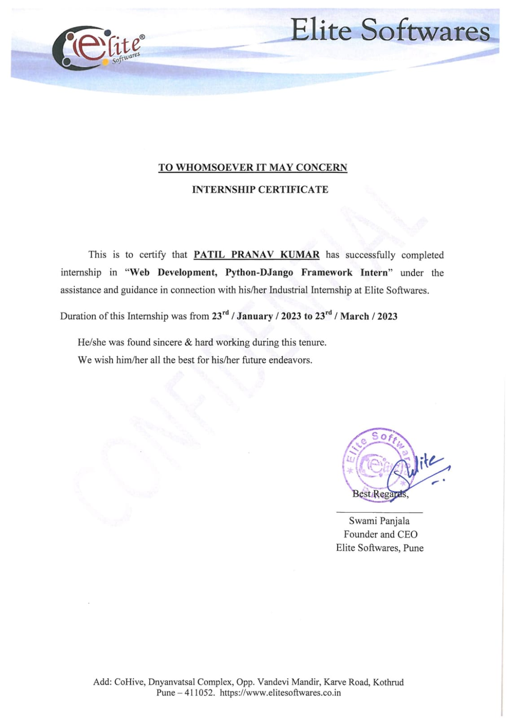

It gives me a great pleasure to acknowledge the contribution of all those who have directly or indirectly contributed to the completion of this seminar.

First of all, I would like to thank my Institute, All India Shri Shivaji Memorial Society's College of Engineering, Pune for arranging an internship program. I am also grateful to **Elite Software** for recruiting me as an intern.

I take this opportunity to express my profound gratitude and deep regards to my supervisor

**Swami Panjala** for his exemplary guidance, monitoring and constant encouragement throughout the course of this internship. The blessing, help and guidance given by him time to time shall cany me a long way in the journey of life on which I am about to embark.

I would like to express my heartfelt gratitude to my faculty mentor **Prof. V. S. Gunjal** our internship Co-Coordinator **Prof. S. G. Dhengre**, HOD **Dr. S. V. Athawale**, Principal **Dr. D. S. Bormane** All India Shri Shivaji Memorial Society's College of Engineering, Pune for their kind support during my internship program.

## Academic Year: 2022-23

Date-

## Name: Pranav Patil Roll No: 20CO089

|  |  |  |
| --- | --- | --- |
| **Sr.No.** | **Content** | **Page No.** |
| 1 | Abstract | 7 |
| 2 | Organization Details | 8 |
| 3 | Responsibilities as an Intern | 9 |
| 4 | Outcomes of Internship | 12 |
| 5 | Internship Experience | 17 |
| 6 | Conclusion | 18 |
| 7 | References | 19 |

**ABSTRACT**

A to-do list is a list of tasks that need to be completed, typically organized in order of priority. It is one of the simplest solutions for task management and provides a minimal and elegant way for managing tasks a person wishes to accomplish.

Our aim is to design a simple and elegant website for people to keep a track of the status of their tasks. Making a to-do list is an easy and important task that everyone should do. The immense satisfaction that one gets when completing the task and marking it on the list are incomparable.

Moreover, creating a list of tasks ensure you don’t miss out on anything. It’s a scientific fact that when you write the tasks that you need to complete, you are even more motivated to complete it. With this in mind, we come to build a platform which will help people create their own task list.

With the help of modern tools and technologies, we strive to build a minimal and efficient to-do list which minimizes distractions and helps people achieve task management with ease and without hassle.

**ORGANISTAION DETAILS**

|  |  |
| --- | --- |
| **Company background-Organization** | Elite Softwares Pune based Software Company since 2011 with more than 1000 Clients and we developed more than 8000 Students for Self Employment in Web Development. |
| **Activities/Scope** | Encompasses all related development activities, such as client-side scripting, server-side scripting, server and network security settings, e-commerce development, and content management system (CMS) development, in addition to web markup and code. |
| **Objective of Study** | Web-Python-Django Development |
| **Supervisor Details(Name,Designation,Company Name,Email_Id,Contact number)** | Mr. Swami Panjala  CEO & Founder of Elite Software  [swami@elitesoftwares.co.in](mailto:swami@elitesoftwares.co.in)  9096622683 |

**RESPONSIBILITES AS AN INTERN**

An Intern’s responsibilities and duties vary drastically depending on the industry and company they work for.

While completing the internship and training program in **Elite Software** we learned enormous new skills and techniques and understood and fulfilled certain responsibilities as an intern and they are as follows:

* Fulfilling tasks assigned by a supervisor
* Performing clerical duties
* Managing social media accounts
* Event handling or planning
* Job shadowing
* Learning technical skills related to the industry
* Discuss progress and engage in discussion of topics relevant to the operation and philosophical perspective of the office and functional area in general.
* Carry out established activities and any additional responsibilities which are mutually agreed upon by the student and site supervisor.
* Fulfill agreed upon time commitments.
* Conduct oneself in a responsible and professional manner.

A general overview of the work you can expect to do as an intern:

**1. Assist and contribute to the team!**

As an intern, don’t expect to spearhead a critical project right off the bat…at least not yet. In the beginning of your internship, you may your time simply trying to learn how the company works. You may shadow an employee to get an understanding of their role. After a day or a few days of learning the ins-and-outs of the company. You’ll start to assist and contribute more to the team.

Here are some day-to-day intern roles and their responsibilities:

* **Performing clerical duties:**
* **Managing social media and emails:**
* **Research**

**2. Learn and gain experience**

You’ll be expected to learn as much as you possibly can while you work, regardless of the kind of internship you’ve signed up forIt can be broken down into two main areas:

* **Picking up hard skills:**Hard skills are the technical skills you need to carry out your intern responsibilities, and eventually job duties, successfully. Examples include learning some technical skills to management skills to understanding data analytics.
* **Brushing up on your soft skills:** Soft skills are as important as hard skills. Soft skills are all about your ability to relate to people and building mutually-beneficial relationships. Examples are emotional intelligence, motivation, people-skills, listening, and excellent communication.

**3. Job shadow**

Job shadowing has become the norm recently. As the name suggests, the practice involves “shadowing” someone as they perform their daily duties, observing their activities, and learning what the role entails via indirect experience. This is an especially popular practice in hands-on fields like engineering and healthcare.

How does this work exactly? When you join the organisation, you may be assigned a mentor. The first few weeks, you may be tasked with following them around.

Once you’ve shadowed for a while, you may be asked to help your mentor on projects or eventually take over some of their tasks.

**4. Take on an increasing amount of responsibility**

As time goes by, expect to shoulder an increasing amount of responsibility. Initially, they’ll gauge your current skill set and reliability with your initial workload. As you prove yourself to your colleagues and bosses, you’ll be entrusted with more crucial tasks

This is an excellent opportunity to showcase your abilities to your employer. It can also help contribute to you receiving a full-time role afterwards. However, don’t feel like you need to shoulder more than you can handle. **Employers prefer quality over quantity** – don’t afraid to ask for help if you need it.  Interns who can display that they can handle additional work and keep with tight deadlines will be more likely to impress the boss.

**5. Network**

While networking isn’t an official requirement as such, it might as well be. Networking involves building relationships with your bosses, colleagues, and customers and clients. You’ll need the backing and support of people in places to build a successful career. Als, building good relationships with customers is always good for the organisation.

Here are some examples of the kind of networking interns do:

* **Finding a mentor:**Mentors act as anchor roles for interns. If you find a good one, you can follow in their footsteps and build a successful career just like your mentor.
* **Forming a peer support group:** Interning is hard. Finding a peer support group who is going through all the ups and downs with you will make it much more enjoyable for everyone involved.
* **Getting in with bosses and coworkers:** Interns who can build strong individual bonds with their coworkers and bosses become a part of the “family”. You’re much more likely to be offered a full-time role at the company down the road.

**6. Make a career call**

Finally, usually at the tail-end of your internship, you have to make a career-defining decision: continue in the field you interned in or try your hand at something else entirely.

**Intern Qualifications / Skills:**

* Verbal communication
* Organization
* Scheduling
* Professionalism
* Customer focus
* Confidentiality
* Adaptability
* Collaboration

**OUTCOME**

WHAT ARE THE ADVANTAGES OF USING A TO-DO LIST APP?

### Increases productivity

### At work and at home, having a to-do list may help you prioritize your work and personal tasks. This allows you to organize and complete the most crucial tasks first.

### Improves memory

### Creating a daily to-do list can help improve your overall memory by reinforcing your short-term memory. By writing tasks and short-term goals and continually checking the list, you might retain more information.

### Reduces stress

### Planning the activities you want to complete each day can help declutter your life and remove a sense of being overwhelmed by everything that needs to be done.

### Provides a sense of accomplishment

### Completing tasks and having a physical action, such as crossing them off a list, can provide a sense of accomplishment.

### Allows for more personal time

### A to-do list can help you organize your time and finish your tasks more efficiently, giving you more free time.

* Learnt Technologies

1. HTML :-

HTML (HyperText Markup Language) is the most basic building block of the Web. It defines the meaning and structure of web content. Other technologies besides HTML are generally used to describe a web page's appearance/presentation (CSS) or functionality/behavior (JavaScript).

"Hypertext" refers to links that connect web pages to one another, either within a single website or between websites. Links are a fundamental aspect of the Web. By uploading content to the Internet and linking it to pages created by other people, you become an active participant in the World Wide Web.

HTML uses "markup" to annotate text, images, and other content for display in a Web browser. HTML markup includes special "elements" such as <head>, <title>, <body>, <header>, <footer>, <article>, <section>, <p>, <div>, <span>, <img>, <aside>, <audio>, <canvas>, <details>, <embed>, <nav>, <output>, <progress>, <video>, <ul>, <ol>, <li> and many others.

1. CSS :-

Cascading Style Sheets (CSS) is a stylesheet language used to describe the presentation of a document written in HTML or XML (including XML dialects such as SVG, MathML or XHTML). CSS describes how elements should be rendered on screen, on paper, in speech, or on other media.

CSS is among the core languages of the open web and is standardized across Web browsers according to W3C specifications. Previously, the development of various parts of CSS specification was done synchronously, which allowed the versioning of the latest recommendations. You might have heard about CSS1, CSS2.1, or even CSS3. There will never be a CSS3 or a CSS4; rather, everything is now CSS without a version number.

1. JAVASCRIPT :-

JavaScript (JS) is a lightweight, interpreted, or just-in-time compiled programming language with first-class functions. While it is most well-known as the scripting language for Web pages, many non-browser environments also use it, such as Node.js, Apache CouchDB and Adobe Acrobat. JavaScript is a prototype-based, multi-paradigm, single-threaded, dynamic language, supporting object-oriented, imperative, and declarative (e.g. functional programming) styles.

JavaScript's dynamic capabilities include runtime object construction, variable parameter lists, function variables, dynamic script creation (via eval), object introspection (via for...in and Object utilities), and source-code recovery (JavaScript functions store their source text and can be retrieved through toString()).

1. BOOTSTRAP :-

Bootstrap is a free and open-source CSS framework directed at responsive, mobile-first front-end web development. It contains HTML, CSS and (optionally) JavaScript-based design templates for typography, forms, buttons, navigation, and other interface components.

Bootstrap is an HTML, CSS and JS library that focuses on simplifying the development of informative web pages (as opposed to web applications). The primary purpose of adding it to a web project is to apply Bootstrap's choices of color, size, font and layout to that project. As such, the primary factor is whether the developers in charge find those choices to their liking. Once added to a project, Bootstrap provides basic style definitions for all HTML elements. The result is a uniform appearance for prose, tables and form elements across web browsers.

* Some Snapshots of the To-Do Interface :-

1) Basic interface of the To-Do Web App

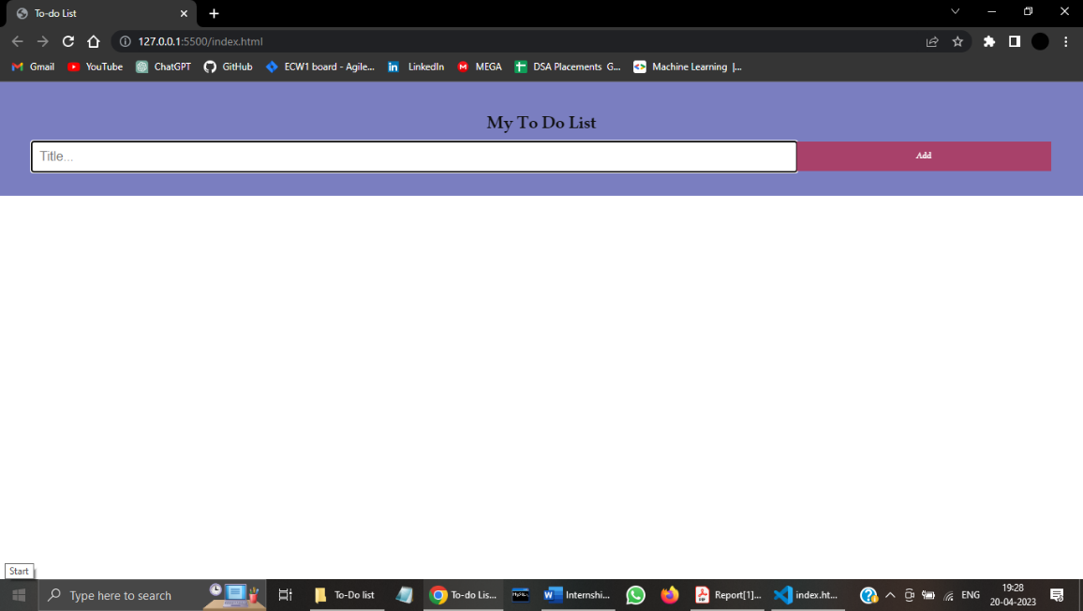

2) After we add the task

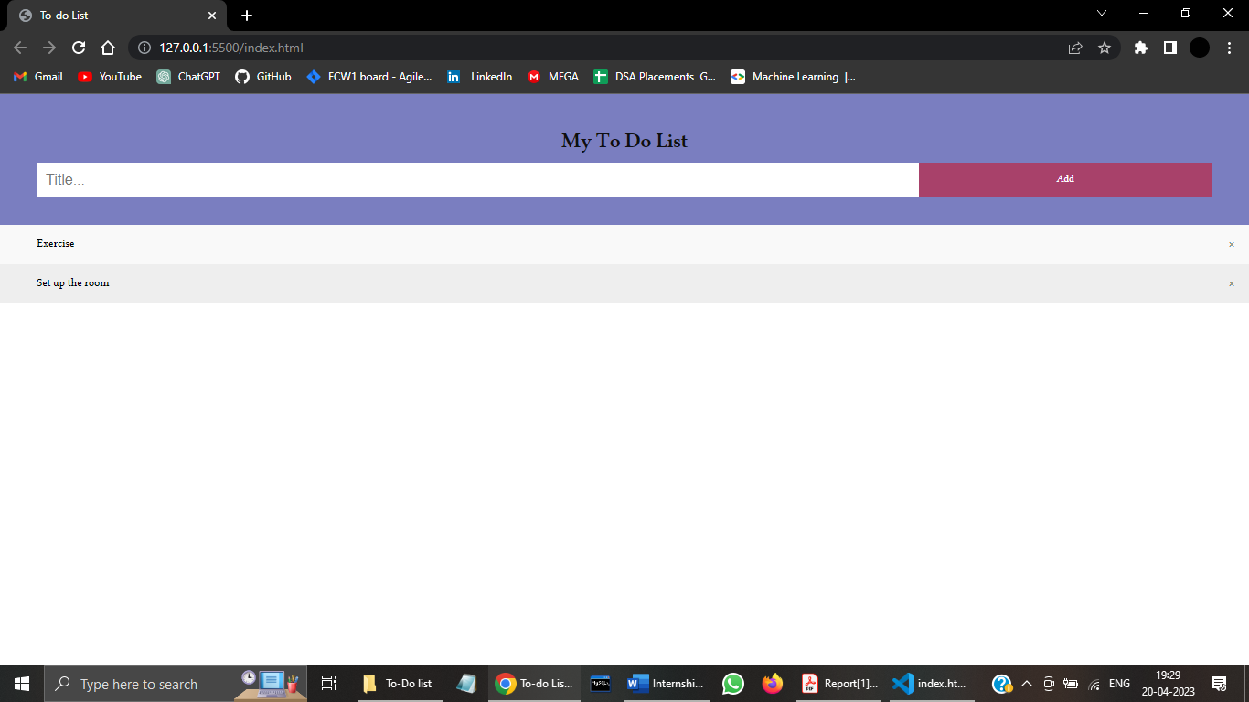

3) After we mark the task as done

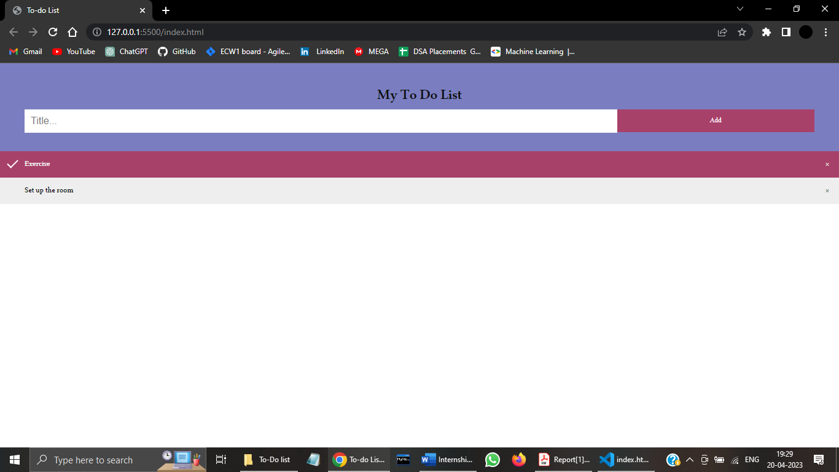

4) Some other tasks are added

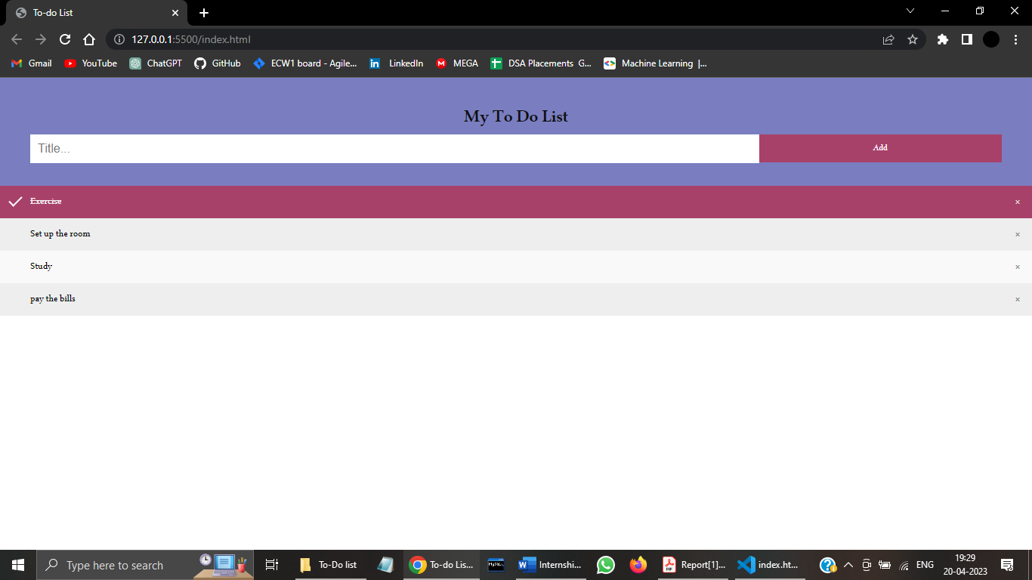

**Internship Experience**

During my internship with the company, I learned all related development activities, such as client-side scripting, server-side scripting, server and network security settings, e-commerce development, and content management system (CMS) development, in addition to web markup and code.

I was able to put these skills in practice in Web Development projects and one such project is this project which is entitled as Computer Department Website. The work was challenging, and I learned web Development using ReactJS, Python and Django framework about the work and gained more confidence in myself. It was a valuable experience.

Internships are usually short-term. They’re smaller investments in time and energy than full-time jobs. But they are certainly without a doubt a great investment of your time. Consequently, they’re perfect opportunities to explore your options. This internship is going to shape the course of my career. It’ll assist me in acquiring the skills you need to perform up-to-par when you’re hired full-time. I am sure to have a bright future if you work hard, build positive relationships, and use the skills you develop in your internship to your advantage.

**Conclusion**

A meaningful and fulfilling career can have a profound impact on your life. It can contribute to your personal growth, improve your well-being, and even enhance your relationships with others. Here, we'll explore some of the ways that career engagement can positively impact various aspects of your life.

In this 60 days, I have learnt how to work as per client requirements and develop accordingly. It improved my way of understanding the idea and delivering it to the clients. It also gave me an experience to submit work before the deadline

On the whole, this internship was useful experience. We have gained now knowledge. Skills and met many people. We achieved our learning goals. We got insight into professional practice currently advocated in the industry. We learned the different facts of working within a well-established industry.

**REFERENCES**

* 1. <https://github.com/PKP2917/Elite_Internship>
  2. <https://developer.mozilla.org/en-US/docs/Web/HTML>
  3. <https://developer.mozilla.org/en-US/docs/Web/CSS>
  4. <https://developer.mozilla.org/en-US/docs/Web/JavaScript>
  5. <https://en.wikipedia.org/wiki/Bootstrap_(front-end_framework)>